**AI BASED DESIGN OF FREQUENCY SELECTIVE SURFACES (FSS)**

**Abstract:**

Frequency Selective Surfaces (FSS) play a crucial role in applications such as radar, satellite communication, and electromagnetic shielding, where precise control over the transmission and reflection of electromagnetic waves is essential. Traditional FSS design methods involve intricate geometric adjustments and time-intensive simulations. This project introduces an AI-based approach to automate and optimize the design of FSS structures using machine learning techniques. A neural network model was developed and trained on transmission coefficient (S21) data across a range of frequencies to accurately predict the optimal design parameters. This approach significantly improves the efficiency, adaptability, and accuracy of the design process while reducing development time. The results demonstrate the potential of AI-driven FSS design to streamline electromagnetic surface engineering.

1. **Introduction**
2. **Proposed Methodology**

• **Data Preprocessing**  
Simulation data comprising structural design parameters and their corresponding transmission coefficients were gathered and organized into a unified dataset for subsequent processing and analysis.

• **Feature and Target Preparation**  
The design parameters served as input features, while the transmission coefficient values were treated as output targets. The dataset was split into training and testing sets to enable effective model evaluation.

• **Model Development**  
A deep learning architecture featuring multiple layers and non-linear activation functions was developed to learn the intricate relationship between design parameters and frequency response behaviour.

• **Parameter Optimization**  
An optimization technique was employed to automatically fine-tune the design parameters, aiming to achieve the desired frequency response. The algorithm iteratively updated parameter values based on performance feedback.

• **Target Definition**  
Desired frequency response characteristics were defined and interpolated across the frequency spectrum to establish clear performance objectives for the optimization process.

• **Optimization and Evaluation**  
The optimization process was carried out over multiple iterations, continually reducing the error between the predicted and target values to determine the most effective design parameters.

• **Result Analysis and Visualization**  
The output of the trained model using the optimized parameters was compared with the target values through graphical visualizations to evaluate the design accuracy and overall model effectiveness.

1. **Design and Analysis**

**3.1 CA-1 (First Review)**

The design is a hexagonal Frequency Selective Surface (FSS) unit cell with a six-legged Swastik-shaped slot at the centre, built on a Rogers RO4003C substrate (εr ≈ 3.38). The hexagonal shape ensures symmetry and efficient packing, while the Swastik slot modifies current paths for optimal stopband performance. Key design parameters include **Leg Length (l)**, which controls the resonant frequency, and **Leg Thickness (t)**, which affects the stopband's bandwidth and strength. The parameter ranges for simulation are: **l**: 1.0 mm – 5.8 mm and **t**: 0.2 mm – 1.0 mm. Ports and periodic boundaries are added to evaluate S-parameters and filtering performance.

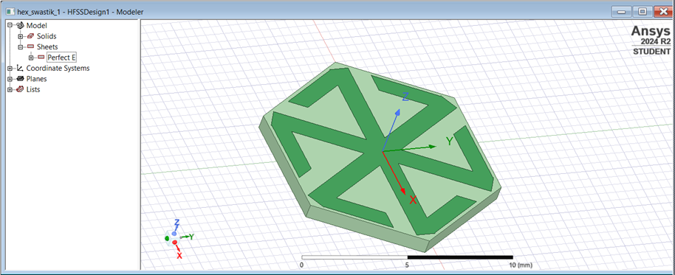

 FR4 Substrate

 Copper Strip

Fig (1) Decagonal FSS Design Structure

**Data Collection Process**

The simulation was carried out using ANSYS HFSS, with the following steps:

1. Design Setup:
   * A single unit cell with periodic boundary conditions was modelled.
   * The Swastik geometry was created with adjustable parameters (l and t).
   * The frequency sweep was set from 2 GHz to 16 GHz.
2. Parametric Sweep:
   * Multiple simulations were run by varying l and t within their defined ranges.
   * For each combination, the S21 (transmission coefficient) was recorded.

This simulation dataset will serve as the foundation for identifying optimal FSS configurations and training predictive models in the next phases of the project.

**3.2 CA-2 (Second Review)**

**3.2.1 Forward Prediction Network**

The neural network used for prediction follows a Feedforward Neural Network architecture, trained in a supervised manner. It consists of:

* **Input Layer**: 3 neurons, representing Frequency, Arm Length, and Arm Thickness.
* **Hidden Layers:**
  + First Hidden Layer: 512 neurons with ReLU activation function.
  + Second Hidden Layer: 1024 neurons with ReLU activation function.
  + Third Hidden Layer: 1024 neurons with ReLU activation function.
  + Fourth Hidden Layer: 512 neurons with ReLU activation function.
* **Output Layer:** 1 neuron, representing the predicted S21 value.

**Custom Loss Function**

A custom weighted loss function is used to give exponentially higher penalties to larger errors, improving the model’s sensitivity in critical regions of the frequency response. This approach prioritizes difficult-to-learn patterns and outliers, ensuring high-accuracy predictions for challenging design scenarios.

**Training Configuration**

* **Loss Function:** Custom Loss to minimize larger prediction errors and enhance performance in key frequency regions.
* **Optimizer:** Adam optimizer with a learning rate of 1e-4 for efficient convergence.
* Early Stopping: Monitors validation loss to prevent overfitting and stops training once performance stagnates.
* **ReduceLROnPlateau:** Reduces the learning rate if the validation loss remains unchanged for a set number of epochs, aiding optimization.

The network is trained using a dataset derived from HFSS simulations, with an 80-20 training-validation split. The trained model rapidly estimates S21 values, reducing dependence on computational simulations during optimization.

**Outcomes:**

Key performance metrics demonstrated:

* **Final Training Loss:** 2.8698e-04
* **Final Validation Loss:** 2.9724e-04

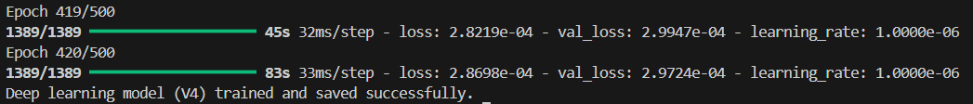

Fig (5.1) Training Results of the Neural Network (FPN)

**3.2.2** **Optimization**

Three optimization frameworks were used in this project to refine the design parameters of the Frequency Selective Surface (FSS). These frameworks combine global search techniques with local refinement for precise convergence. The following optimization strategies were employed:

A **custom objective function** prioritizes both the width and depth of the stopband by evaluating predicted S21 values from the Forward Prediction Network (FPN). It identifies the stopband frequency range where S21 is below the desired threshold, calculates the bandwidth (f2 – f1) and average attenuation (avg_S21) within this range. The function returns a negative score, −(stopband width × (−avg_S21)1.5), where larger, deeper stopbands yield better (more negative) values, guiding optimization towards effective parameter selection.

**1. Initialization:**

* A population of individuals is randomly generated, each encoding a set of FSS parameters.

**2. Global Search:**

* **Genetic Algorithm (GA):** This step explores the parameter space broadly.
  + **Selection:** High-fitness individuals are selected to form the next generation.
  + **Crossover:** New solutions are generated by combining the parameters of selected individuals.
  + **Mutation:** Introduces diversity by randomly altering design parameters.

**3. Prediction:**

* The FPN is used to evaluate the performance of each individual by predicting the S21 values for the given parameter set.

**4. Local Refinement:**

* Simulated Annealing (SA) is applied to the best-performing solutions from GA to refine them.
  + **Perturbation:** Iteratively perturb the solutions to explore their neighbourhood.
  + **Acceptance:** Accept new solutions based on temperature-dependent probability.
  + **Cooling:** Gradually reduce the temperature to guide the system toward optimal solutions.

**5. Output:**

* The best configuration, characterized by maximum bandwidth and minimum insertion loss, is recorded.

**Outcomes:**

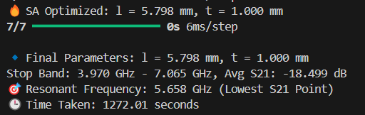

Fig (5.3) Results of the GA + SA Optimization

**Output:**

**Optimal FSS parameters of GA+SA**

🔹 Final Parameters: l = 5.798 mm, t = 1.000 mm

Stop Band: 3.970 GHz - 7.065 GHz, Avg S21: -18.499 dB

🎯 Resonant Frequency: 5.658 GHz (Lowest S21 Point)

**Visualization:**

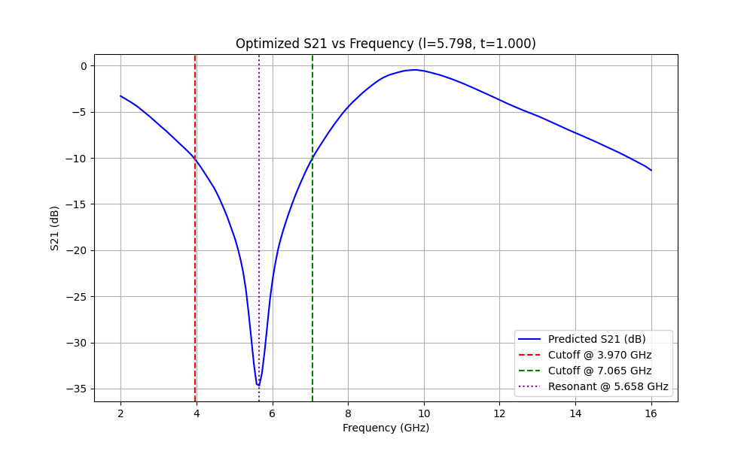

Fig (5.4) Visualization of S21 values Optimized Parameters by GA+SA

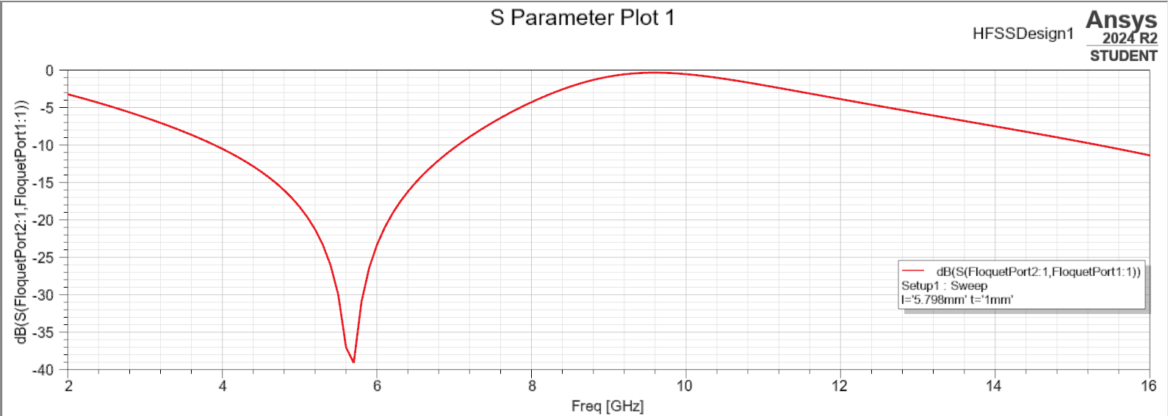

Fig (5.5) Simulated S21 Plot of Optimized Parameters

1. **Final Review**

To Enhance the output and decrease the computational time and improve the efficiency by using improved techniques.

**Optimal FSS parameters of NSGA-II+SA**



Fig (6.4) Results of the NSGA + SA Optimization

**Output Plot:**

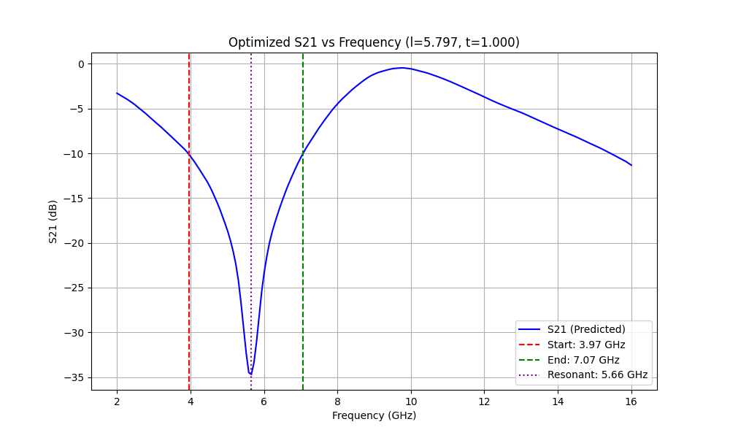

Fig (6.5) Visualization of S21 values Optimized Parameters by NSGA+SA



Fig (6.6) Simulated S21 Plot of Optimized Parameters

**Optimal FSS parameters of PSO+SA**

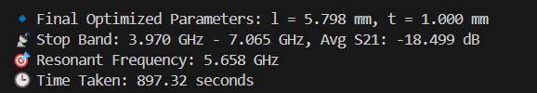

Fig (6.1) Results of the PSO + SA Optimization

**Visualization:**

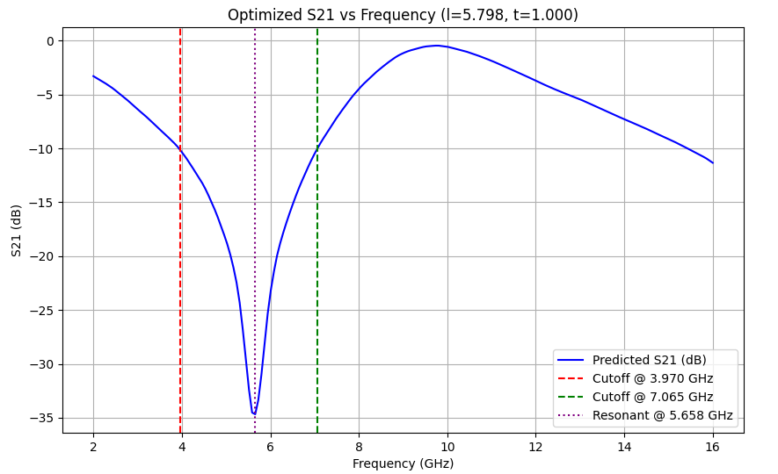

Fig (6.2) Visualization of S21 values Optimized Parameters by PSO+SA



Fig (6.3) Simulated S21 Plot of Optimized Parameters

Table 6.1: Comparative Analysis of Hybrid Optimization Approaches for FSS Parameter Tuning

|  |  |  |  |  |  |
| --- | --- | --- | --- | --- | --- |
| Optimization Approach | Optimized Parameters (l, t) | Stop Band (GHz) | Average S21 (dB) | Resonant Frequency (GHz) | Time (seconds) |
| GA + SA | l = 5.798 mm  t = 1.000 mm | 3.970 – 7.065 | -18.499 | 5.658 | 1272.01 |
| NSGA-II + SA | l = 5.797 mm  t = 1.000 mm | 3.970 – 7.065 | -18.497 | 5.658 | 900.15 |
| PSO + SA | l = 5.798 mm  t = 1.000 mm | 3.970 – 7.065 | -18.499 | 5.658 | 897.32 |

The comparative analysis in Table 6.1 demonstrates that all hybrid optimization techniques achieved nearly identical performance in terms of stopband, average S21, and resonant frequency. However, the combination of Particle Swarm Optimization with Simulated Annealing exhibited the fastest convergence time, making it the most time-efficient approach among the evaluated methods.

1. **Conclusion**

The AI-based approach, combining Forward Prediction Networks (FPN) with hybrid optimization techniques (GA + SA, NSGA-II + SA, PSO + SA), offers a fast and accurate method for designing Frequency Selective Surfaces (FSS). By leveraging machine learning for quick S21 prediction and optimization algorithms for parameter tuning, it significantly reduces computational time compared to traditional simulations. This approach efficiently optimizes FSS parameters and shows strong potential for rapid, precise design in RF and microwave applications.